2026 Service Revisions
Draft Report for Public Input

Prepared for:
Performance Monitoring and External Relations
11/5/2025

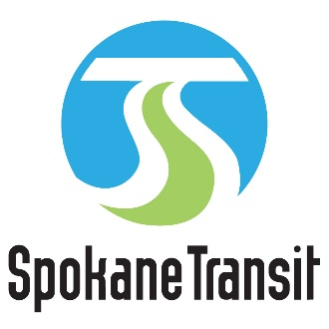

Upon request, alternative formats of this document will be produced for people with disabilities. Please call (509) 325-6094 or TTY (509) 232-6555 or email ombudsman@spokanetransit.com

Table of Contents
1.0 Executive Summary 1
1.1 Introduction 1
1.2 Background 1
1.3 Summary of Planned Revisions 2
1.4 North Idaho Pilot Related Improvements 3
2.0 Development of the 2026 Service Revisions Draft Report 4
2.1 Service Change and Planning Timeline 4
2.2 Adopted Plans and Programs 5
Connect Spokane 5
STA Moving Forward 5
2026-2031 Transit Development Plan 5
Connect 2035 6
3.0 Planned Revisions 7
Service Frequency Characteristics 7
3.1 Service Revisions by Route 8
Route 12 Southside Medical Shuttle 8
Route 20 SFCC 9
Route 23 Maple/Ash 11
Route 36 North Central 12
Route 223 Shadle/Indian Trail 14
3.2 Notable Interline Changes 16
Route 33 Wellesley 16
Route 35 Francis/Market 17
3.3 Mead Service Concept 17
3.4 Timeline of Changes 19
4.0 Special Considerations 20
4.1 Title VI Implications 20
4.2 Paratransit Impacts 20

1.0 Executive Summary

1.1 Introduction
This draft report outlines planned service improvements and revisions for 2026. North Spokane is the focus area of these revisions where routing and schedule changes are proposed for some of the routes.
Revisions included herein are informed by the approved 2026-2031 Transit Development Plan (TDP), 2025 Service Revisions Final Report, and past decisions by the Spokane Transit Authority (STA) Board of Directors. This report aims to address in a conservative manner current and future resource availability, in addition to responding to community feedback and system performance reviews. The draft report presented here will be brought before the executive team, PMER Committee, and solicit rider input and community feedback before being refined into a final report.

1.2 Background
Since 2017, STA has been investing in more and better bus service across the Spokane region in line with the STA Moving Forward plan first adopted in 2014 and predicated on funding approved by voters in November 2016. The plan identified more than two dozen projects that expand the extent of public transportation in the region, as well as invest in six corridors recognized in the Agency’s comprehensive plan, Connect Spokane, as High Performance Transit (HPT) corridors. The 2026 introduction of service to North Idaho will be the culmination of the STA Moving Forward’s implementation.
Planning decisions and actions, such as those described above and outlined in greater detail in Section 2 below, inform the annual preparation of the Service Improvement Program (SIP), a section of the state-required Transit Development Plan (TDP), and provide a timeline and program for service changes and adjustments for a three-year period. The most recent TDP includes the 2026-2028 SIP. That plan called for additional service increases and changes in 2026 including the following:
- A restructuring of multiple north Spokane serving routes
- Network schedule recalibration—with the sunset and delivery of the remaining STA Moving Forward Projects, deliberate recalibration of schedules, timepoint, and connection windows will be refined
- The Introduction of service between Mirabeau Transit Center and Kootenai County, Idaho—This pilot service is subject to a partnership with one or more public entities in North Idaho; information will follow in a separate report when conditions for publication are appropriate
The Fixed Route network in current operation (September 2025) represents an investment of approximately 540,325 annual revenue hours. In aggregate, the proposed service revisions and investments represent an approximate increase of 1.38% over existing service, as shown in Table 1 below.
Table 1 – Comparison of Annualized Revenue Service Hours (rounded)
Service Improvement | Annualized Service Hours
1. North Idaho Pilot | 4,960
2. Other 2026 Service Improvements | 2,483
Subtotal | 7,443
Current Operation (September 2025): | 2026 Service Revisions Total
540,325 | 547,768
Note: values are approximate
Due to the North Idaho pilot service being discussed and approved outside the purview of these revisions, only the hours included in the second line of the table above (2. 2026 Other Service Improvements) are included in this proposal for public input and STA CEO approval. These routes are listed in Section 1.3 below.

1.3 Summary of Planned Revisions
Table 2 below provides a list of the proposed revisions to STA’s fixed route network included in the 2026 Service Revisions Draft Report for Public Input as compared with existing conditions (North Idaho Pilot service is summarized in Section 1.4 below). Presented are all routes identified for revision in 2026. It is important to note that minor scheduling changes to other routes not listed below will occur. Implementation of these proposed changes is planned for May and September 2026, subject to CEO approval.
Section 3 of this report provides additional details for each proposed change, including their relationship to STA Moving Forward, changes from existing service, and if the change has a relationship to Connect 2035.
Table 2 – Summary of Planned Revisions
Route | Draft 2026 Service Revisions
12 Southside Medical Shuttle | Alter route to travel Wall Street between 5th and 6th Avenues in both inbound and outbound directions.
20 SFCC | Discontinue service through Peaceful Valley on Main and Clarke avenues. Detach route from Route 33 interline and revise route to be interlined with an extended Route 36. Weekday frequency will be reduced to every 30 minutes.
23 Maple/Ash | Routing will be changed from using the couplet on Maple and Ash Streets between Rowan and Garland Avenues to service on Belt Street.
33 Wellesley* | Disconnect route from interline with Route 20 at SFCC.
35 Francis/Market* | Disconnect route from interline with Route 36.
36 North Central | Extend route to Hillyard east of US-395 and to the north in the vicinity of the URM warehouse near Freya Street and Lincoln Road. Route is planned to be interlined with Route 20 at SFCC.
223 Shadle/Indian Trail | Afternoon routing will be changed from using the couplet on Maple and Ash Streets between Rowan and Garland Avenues to service on Belt Street.
257 Mead Service Concept | Planning staff is exploring the possibility of providing peak service (two morning and two afternoon trips), connecting Mead with other areas in north Spokane.
* These routes are discussed more in Section 3.2 (Notable Interline Changes)

1.4 North Idaho Pilot Related Improvements
Implementation of service into Idaho is predicated on successful negotiations with stakeholders within that state. A separate North Idaho Pilot Report will follow the above-mentioned negotiations. Publication and public input will occur once conditions are appropriate.

2.0 Development of the 2026 Service Revisions Draft Report
Changes and additional service embodied in the 2026 Service Revisions Draft Report for Public Input are grounded in multiple Board-adopted documents, are responsive to customer input, and seek to address operational constraints. STA’s Service Development department works collaboratively with other workgroups inside STA in planning and implementing changes to Fixed Route service. This includes work through an internal working group known as the Service Improvement Committee (SIC). The information below identifies the varying inputs that have informed the work of the Service Development Department and SIC in preparing the recommended elements of the 2026 Service Revisions Draft Report for Public Input as published.

2.1 Service Change and Planning Timeline
The service planning process for the 2026 revisions has been ongoing since August 2024, when Service Development staff conducted inventory of resources, investigated opportunities for changes, and established and vetted goals.
A presentation of this report was given to the Service Improvement Committee, as well as the STA Executive Team. In November and December, STA will gather input on the 2026 Service Revisions Draft Report for Public Input via an online survey and at various other outreach opportunities. Staff will also engage with neighborhood groups and other stakeholders to ensure meaningful feedback is received.
Table 3 below outlines the remaining milestones for public input and finalization of the 2026 service revisions.

Table 3 – Key Activities for 2026 Service Revisions Schedule
Service Revisions Activity | Estimated Date
PMER Committee Review of 2026 Draft Report | November 5, 2025
Public Input on 2026 Service Revisions Draft Report | November 13 – December 15, 2025
Interim Report presented to PMER | December 3, 2025
Final Report to Board | February 2026

Service Change Dates
In accordance with the collective bargaining agreement between ATU 1015 and STA, the dates of the 2026 service changes are:
- January 18, 2026
- May 17, 2026
- September 20, 2026

2.2 Adopted Plans and Programs

Connect Spokane
Adopted in 2010, Connect Spokane: A Comprehensive Plan for Public Transportation is Spokane Transit’s plan that sets forth a vision and policy framework, guiding decisions that will further Spokane Transit’s mission and vision. This includes principles and policies informing the design of Fixed Route service, including the attributes of route pathways, frequency, and span. Connect Spokane also articulates a vision for High Performance Transit, along with corresponding principles and policies, which have informed all stages of route planning.

STA Moving Forward
STA Moving Forward is a 10-year plan to increase transit service, maintain the existing infrastructure, and expand transit coverage to new areas. STA Moving Forward focuses on four main strategies: design and deliver core infrastructure, advance, and implement high performance transit (HPT), improve customer service, and look into the future. Two of the goals outlined in the plan are to improve routes and frequency to Hillyard and Northeast Spokane and to provide service between Spokane and North Idaho, which these proposed revisions would support. Section III of this report identifies any connections to STA Moving Forward a particular route revision may have.

2026-2031 Transit Development Plan
The 2026-2031 Transit Development Plan (TDP) outlines mid-range guidance over a six-year period. It includes the 2026-2028 Service Improvement Program (SIP) which provides a timeline for all anticipated service changes, including both approved and planned changes. Section 3 of this report acknowledges the proposed revisions alignment with or departure from the TDP on a route-by-route basis. The TDP incorporated service changes and improvements approved by the Board.

Connect 2035
In 2022, STA embarked on the development of its next 10-year strategic plan, Connect 2035. The first phases of the planning efforts culminated with the adoption of a strategic foundation document in December 2022 (Board Resolution No. 803-22). The document articulates the high-level roadmap for bus, paratransit, and rideshare service through 2035, with a clear vision supported by goals and strategies. The goals are:

- Elevate the customer experience.
- Lead and collaborate with community partners to enhance the quality of life in our region.
- Strengthen our capacity to anticipate and respond to the demands of the region.

Connect 2035 was adopted in December 2024 (Board Resolution No. 831-24),

3.0 Planned Revisions
In this section the planned revisions are presented in greater detail. Each route that is considered for proposed service revisions, either from existing service or from approved and/or planning changes listed in the TDP, are listed below. Each route includes a table detailing the recommended changes, their relationship to STA Moving Forward, existing service, the TDP and Connect 2035. A brief discussion follows to enhance the understanding of the proposed revision. A map is also included where the route is new or where the route pattern is adjusted from existing service.

Service Frequency Characteristics
The table below outlines the proposed frequency of service for each of the new and modified routes discussed in this draft report. This table is intended to provide planning level assumptions, and the final schedules will be developed prior to the service change. Minutes in bold represent frequency changed from existing conditions. Maps and a guide to existing service frequency can be found online for additional comparisons: https://www.spokanetransit.com/routes-schedules/sta-system-map/.
Table 4 Proposed Service Frequency
Proposed Approximate Frequency (Minutes)
Route | AM Weekday Peak | Mid-Weekday | PM Weekday Peak | Weekday Evening | Saturdays | Sundays
12 | 30 | 30 | 30 | 60 | 30 | 60
20 | 30 | 30 | 30 | 30 | 30 | 60
23 | 30 | 30 | 30 | 60 | 60 | 60
223 | Targeted Trips | -- | Targeted Trips | -- | -- | --
257 | Targeted Trips | -- | Targeted Trips | -- | -- | --

3.1 Service Revisions by Route

Route 12 Southside Medical Shuttle
Proposed Revision | Operate route solely on Wall Street between 5th and 6th Avenues instead of using Howard Street inbound (northbound).
Relationship to STA Moving Forward | This change is not included in STA Moving Forward.
Changes from 2026-2031 TDP | This change is not included in the 2026-2031 TDP
Relationship to Connect 2035 | N/A

Due to operator feedback, STA staff are exploring a route change on Route 12. Coach operators have identified the use of southbound Howard Street to westbound 5th Avenue as potentially hazardous and time consuming during the release time of adjacent Lewis and Clark High School. Mirroring the established outbound (southbound) route path, Route 12 is planned to use Wall Steet when traveling between 6th and 5th avenues northbound.
Figure 1 – Route 12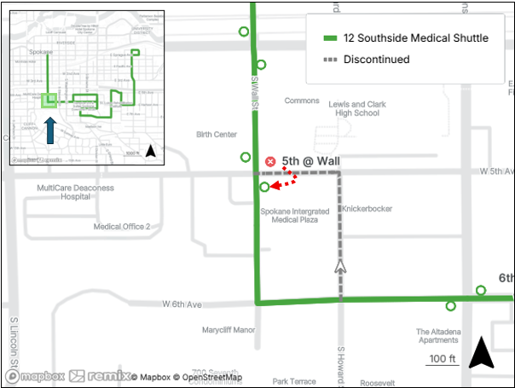
Figure 1 above shows the one-block change to Route 12 bidirectionally using Wall Street in favor or Howard Street. This change requires the closure of the current stop at the northeast corner of 5th Avenue and Wall Street. Stop placement of an alternate location is being explored nearby, either on its own or consolidated with the stop at 4th Avenue.

Route 20 SFCC
Proposed Revision | Operate route solely on Riverside Avenue with 30-minute weekday frequency. Detach the interline from Route 33 and instead interline with Route 36 at SFCC.
Relationship to STA Moving Forward | This change is not included in STA Moving Forward.
Changes from 2026-2031 TDP | No change
Relationship to Connect 2035 | Network Optimization

Route 20 will discontinue service through Peaceful Valley starting September 2026 (see Figure 2). Routing on Clarke Avenue, Maple Street, and Main Avenue will be ended in favor of all-day routing on Riverside Avenue with 30-minute frequency. Ridership at the stops in the Peaceful Vally segment has consistently underperformed and the resources used to provide 30-minute weekday service on the Clarke Avenue and Main Avenue segment will be reallocated to other service.
Figure 2 – Route 20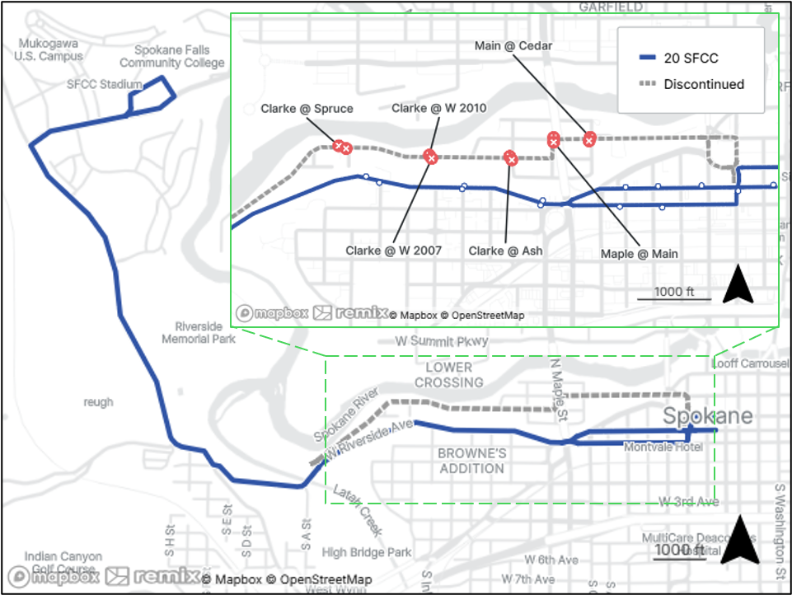
At Spokane Falls Community College (SFCC), Route 20 will no longer be interlined with the 15-minute service provided by Route 33 due to Route 20 operating on a reduced 30-minute frequency. Route 36—with a route extension in Hillyard, described below in more detail—provides better opportunity for interlining at SFCC since both routes will operate with 30-minute frequency. One seat ride service from Downtown Spokane to the Shadle Shopping Center will still be provided by a new route path for Route 23 on Belt Street, bisecting Shadle Center and Shadle Park (more information on this change below).
Table 5 below lists the stops that will be discontinued with the removal of the Peaceful Valley service and the estimated walking distance to the nearest stop. Due to the elevation of the hillside in Peaceful Valley, the nearest stops are only accessible via the Spruce Street (*) or Cedar Street (**) stairs. However, as of this writing, only the stairs at Cedar Street are open. The Spruce Street stairs are currently closed and in need of replacement which is unfunded. Furthermore, these distances do not consider the elevation gain from the valley to Riverside Avenue. With that information known, Table 2 below details the stops on the western side of the neighborhood that are affected by the Spruce Street stairway closure. Alternate stop locations are given with the Spruce Street stairs closed. The stops in the center of the neighborhood (Clarke Avenue @ W 2007 and Clarke Avenue @ W 2010) will find walking east to the Cedar Street stairs a closer, if not more strenuous walk (as they will still need to ascend the stairway).
Table 5 – Route 20 Discontinued Stops
Discontinued Stop | On | Off | Closest Alternate Stop | Distance
Clarke Avenue @ Spruce Street (IB) | 1 | 1 | Riverside Avenue @ Hemlock Street (IB) | 850 ft*
Clarke Avenue @ W. 2007 (IB) | 0 | 0 | Riverside Avenue @ Hemlock Street (IB) | 1,970 ft*
Clarke Avenue @ Ash Street (IB) | 0 | 0 | 1st Avenue @ Adams Street (IB) | 2,000 ft**
Maple Street @ Main Street (IB) | 2 | 0 | 1st Avenue @ Adams Street (IB) | 1,800 ft**
Main @ Cedar (IB) | 3 | 0 | 1st @ Adams (IB) | 1,200 ft**
Main @ Cedar (OB) | 1 | 2 | Sprague @ Adams (OB) | 1,100 ft**
Main @ Maple (OB) | 1 | 2 | Sprague @ Adams (OB) | 1,685 ft**
Clarke @ Ash (OB) | 0 | 0 | Sprague @ Adams (OB) | 1,925 ft**
Clarke @ W. 2010 (OB) | 0 | 0 | Riverside @ Hemlock (OB) | 1,770 ft*
Clarke @ Spruce (OB) | 0 | 1 | Riverside @ Hemlock (OB) | 800 ft*
* Requires ascending the Spruce Street stairway, if open
** Requires ascending the Cedar Street stairway, if open

Table 6 – Spruce Street Stairway Related Stops (West Peaceful Valley)
Discontinued Stop | Closest Stop (not considering Spruce Street stairs) | Distance
Clarke @ Spruce (IB) | Riverside @ A Street (IB) | 2,730 ft
Clarke @ W. 2007 (IB) | 1st @ Adams (IB) | 3,080 ft**
Clarke @ W. 2010 (OB) | Sprague @ Adams (OB) | 3,060 ft**
Clarke @ Spruce (OB) | Riverside @ A Street (OB) | 2,370 ft
** Requires ascending the Cedar Street stairway, if open

Route 23 Maple/Ash
Proposed Revision | Revise route to utilize Belt Street between Garland Avenue and Rowan Avenue instead of the Maple/Ash couplet.
Relationship to STA Moving Forward | This change is not included in STA Moving Forward.
Changes from 2026-2031 TDP | No change
Relationship to Connect 2035 | Network Optimization

Disconnecting the interline of Routes 20 and 33 will change passenger travel between the Shadle Shopping Center and downtown Spokane (discussed further in Section 3.2). To mitigate this disruption and better serve the ridership generators west of Shadle High School, the route path of Route 23 will be revised to travel on Belt Street between Garland and Rowan Avenues. This change will allow Route 23 continued service to Shadle Park High School along with better service to Walmart and the Shadle public swimming pool and library.
The map in Figure 3 below shows the discontinued Route 23 stops in red and stops that will be newly constructed as part of this realignment as blue circles. Table 3 below the map details the closest Route 23 stops (?) to those discontinued stops and the estimated walking distance. Note that Route 33 will continue to serve Wellesley Avenue, providing any previous connections to Route 23 at Belt Street.
Figure 3 –Route 23 with Closed and New Stops
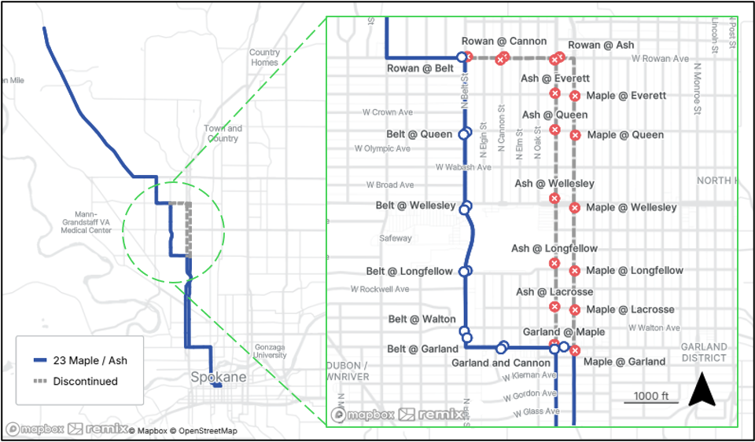

Table 7 – Route 23 Discontinued Stops
Discontinued Stop | On | Off | Closest Alternate Stop (Route 23) | Distance
Rowan @ Cannon (IB) | 6 | 0 | Rowan @ Belt (IB) | 685 ft
Rowan @ Ash (IB) | 11 | 1 | Rowan @ Belt (IB) | 1,685 ft
Ash @ Everett (IB) | 3 | 0 | Rowan @ Belt (IB) | 2,300 ft
Ash @ Queen (IB) | 4 | 1 | Belt @ Queen (IB) | 1,730 ft
Ash @ Wellesley (IB) | 37 | 32 | Belt @ Wellesley (IB) | 1,830 ft
Ash @ Longfellow (IB) | 34 | 126 | Garland @ Ash (IB) | 1,600 ft
Ash @ Lacrosse (IB | 5 | 2 | Garland @ Ash (IB) | 800 ft
Ash @ Garland (IB) | 49 | 6 | Garland @ Ash (IB) | 150 ft
Maple @ Garland (OB) | 12 | 37 | Garland @ Maple (OB) | 250 ft
Maple @ Lacrosse (OB) | 9 | 7 | Garland @ Maple (OB) | 875 ft
Maple @ Longfellow (OB) | 26 | 24 | Garland @ Maple (OB) | 1,595 ft
Maple @ Wellesley (OB) | 39 | 37 | Belt @ Maple (OB) | 2,000 ft
Maple @ Queen (OB) | 1 | 5 | Belt @ Queen (OB) | 2,040 ft
Maple @ Everett (OB) | 0 | 3 | Belt @ Queen (OB) | 2,660 ft
Rowan @ Ash (OB) | 1 | 12 | Rowan @ Belt (OB) | 1,850 ft
Rowan @ Cannon (OB) | 0 | 5 | Rowan @ Belt (OB) | 835 ft
Rowan @ Belt (OB) | 1 | 6 | Rowan @ Belt (OB) | 150 ft

Route 36 North Central
Proposed Revision | Route extended to serve East Hillyard via Freya Street.
Relationship to STA Moving Forward | This change is not included in STA Moving Forward.
Changes from 2026-2031 TDP | No change
Relationship to Connect 2035 | Network Optimization

Route 36 will extend beyond its current terminus at Garland Avenue and Regal Street to Hillyard east of the North Spokane Corridor. Due to this extension, Route 35 will no longer be able to provide an interline partner with Route 36. The new route path for Route 36 will transverse under US 395 at Wellesley Avenue and serve Freya Street north of Wellesley Avenue. Customer input from residents in the east Hillyard neighborhood has long indicated a need for fixed route bus service in this area. With the construction of the US 395 interchanges at Wellesley Avenue, the road now is improved to be safe for bus travel.
Figure 4 below presents Route 36 with the proposed area of extension as described above, along with its new interline partner, Route 20. The interline with Route 20 can provide passengers with a one-seat ride between Hillyard and downtown Spokane. Current transfers to other routes from Route 36 at other major north/south transfer nodes will be maintained. Transfer opportunities will still exist with Route 35 in Hillyard as well.
Figure 4 - Route 36
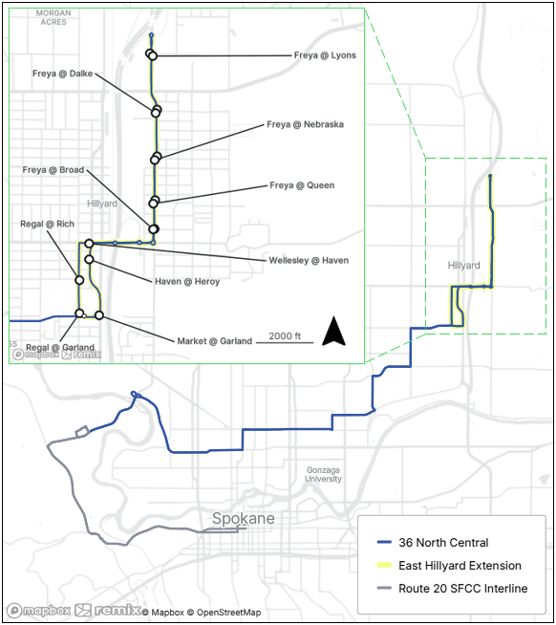
The US 395 interchange roundabout with Freya Street (south of the highway) is identified as the turnaround location for this route. Stops and other locations for passenger amenities are still being investigated for this extension. Ridership generators, current stop spacing standards, and safety considerations will be made before determining final stop locations.

Route 223 Shadle/Indian Trail
Proposed Revision | Revise route to utilize Belt Street between Garland Avenue and Rowan Avenue instead of the Maple/Ash couplet.
Relationship to STA Moving Forward | This change is not included in STA Moving Forward.
Changes from 2026-2031 TDP | No change
Relationship to Connect 2035 | Network Optimization

Since Route 223 is a targeted route providing augmented service to Route 23, the proposed routing change to Route 23 (see above) and related stop closures supports a change to Route 223. However, Route 223 will not fully mirror the proposed change to Route 23. Unchanging is the inbound morning trip via Ash Street. The northbound PM trip is proposed to use Belt Street between Garland and Rowan avenues, mirroring the outbound (northbound) Route 23. The stop for Shadle Park High School will shift to Belt Street and Longfellow Avenue on the afternoon trip. The morning trip will still serve the stop at Ash Street and Longfellow Avenue.

The map in Figure 5 below shows the discontinued Route 223 stops in red and shared stops to be constructed for both Routes 23 and 223 as part of this realignment as larger pink circles. It is recognized that students living within the boundary of North Central High School between Garland Avenue and Rowan Avenue will not have paired boarding and alighting locations with this routing change. These students may also consider the seven-block walk between the closed stops on Route 223 and Route 4 (Figure 6) on Monroe Street as an alternative commute option offering weekday 15-minute service to North Central High School. The table below compares distances between the closed Route 223 stops and comparable alternate stops to Route 4 or routes 23 and 223.

Table 8 – Route 223 Discontinued Northbound (OB) Stops
Discontinued OB Stop | On | Off | Closest Stop Rt. 23/223 | Distance | Closest Stop Rt. 4 | Distance
Maple @ Garland | 12 | 37 | Garland @ Maple | 250 ft | Monroe @ Garland | 2,200 ft
Maple @ Lacrosse | 9 | 7 | Garland @ Maple | 875 ft | Monroe @ Longfellow | 2,930 ft
Maple @ Longfellow | 26 | 24 | Garland @ Maple | 1,595 ft | Monroe @ Longfellow | 2,200 ft
Maple @ Wellesley | 39 | 37 | Belt @ Maple | 2,000 ft | Monroe @ Wellesley | 2,200 ft
Maple @ Queen | 1 | 5 | Belt @ Queen | 2,040 ft | Monroe @ Queen | 2,200 ft
Maple @ Everett | 0 | 3 | Belt @ Queen | 2,660 ft | Monroe @ Rowan | 2,850 ft
Rowan @ Ash | 1 | 12 | Rowan @ Belt | 1,850 ft | Monroe @ Rowan | 2,500 ft
Rowan @ Cannon | 0 | 5 | Rowan @ Belt | 835 ft | Monroe @ Rowan | 3,500 ft
Rowan @ Belt | 1 | 6 | Rowan @ Belt | 150 ft | Monroe @ Rowan | 4,200 ft

Figure 5 – Route 223 New and Discontinued Routing and Stops
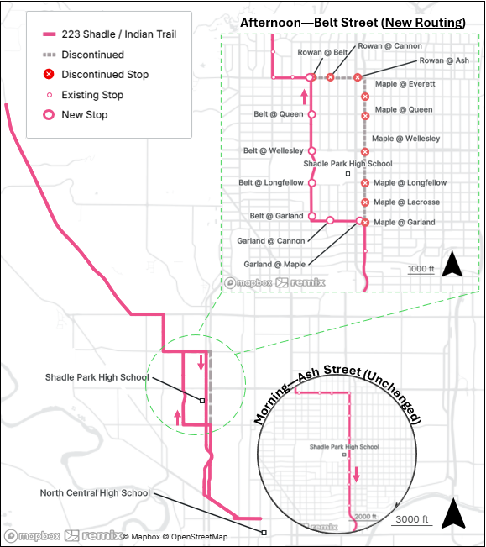

Figure 6 – Route 223 Closed Stops and Route 4
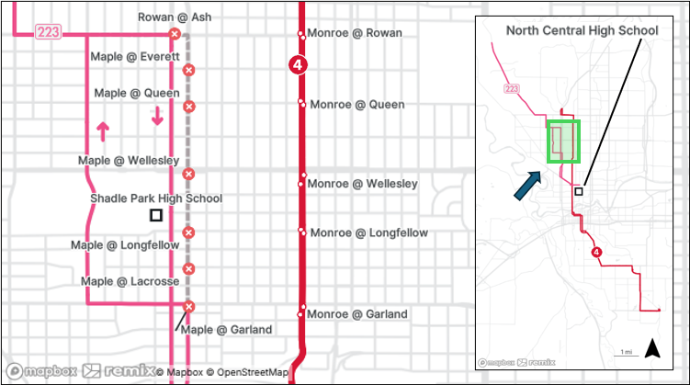

3.2 Notable Interline Changes
As discussed above, Route 20 is proposed to operate on a reduced frequency. At Spokane Falls Community College (SFCC), Route 20 will operate on a 30-minute frequency and no longer be a suitable candidate for interlining with the 15-minute service provided by Route 33. Therefore, Route 20 is proposed to be interlined with the 30-minute service provided on Route 36, which is proposed for extension in Hillyard, described above.
Routes which are affected by the new interline between routes 20 and 36 are discussed below.

Route 33 Wellesley
Proposed Revision | Disconnect interline with Route 20 at SFCC
Relationship to STA Moving Forward | This change is not included in STA Moving Forward.
Changes from 2026-2031 TDP | This change is not explicitly included in the 2026-2031 TDP, though implied with new interline between routes 20 and 36
Relationship to Connect 2035 | Network Optimization

Disconnecting the interline of Routes 20 and 33 will disrupt passenger travel between the Shadle Shopping Center and downtown Spokane. Westbound Route 33 has often been the preferred path of travel to downtown Spokane by passengers departing the Shadle Center. The interline with Route 20 and short recovery at SFCC provided a direct one-seat ride with little dwell time.
However, as discussed above, the STA proposed adjustment to Route 23 to travel adjacent to the Shadle commercial center, library, park and swimming pool on Belt Street, provides a mitigation for the loss direct 20-to-33 service. It is also important to note that the transfer connection between Routes 20 and 33 will still exist at Spokane Falls Community College. However, the one-seat ride will not.

Route 35 Francis/Market
Proposed Revision | Interline with Route 36 disconnected
Relationship to STA Moving Forward | This change is not included in STA Moving Forward.
Changes from 2026-2031 TDP | This change is not explicitly included in the 2026-2031 TDP, though implied with new interline between routes 20 and 36
Relationship to Connect 2035 | Network Optimization

A consequence of the extension to Route 36 (see above) is that the route will no longer be available to interline with another route at Regal Street and Garland Avenue. Due to this, the interline which Route 35 shares with Route 36 will be discontinued. Without another route commencing at Regal Street and Garland Avenue, Route 35 will be required to perform a westbound Route 35 service upon arrival after performing the eastbound.

3.3 Mead Service Concept
In response to a request from the Mead School District, STA staff are exploring the possibility of implementing a new targeted route to connect the community of Mead with north Spokane in partnership with the Mead School District. The concept—tentatively numbered Route 257 and sketched in Figure 7 below—is to provide bidirectional trips connecting the Fairwood neighborhood with Shiloh Hills via Mead. Scheduling in this concept provides two trips on weekday mornings and two to three more in the afternoon, adjacent to high school bell times.
The Shilo Hills neighborhood of north Spokane lies within the Mead School District. These students, though served very well by the STA network to other points in Spokane, do not have easy bus access to Mount Spokane High School as it does not lie within the PTBA. Likewise, the community of Mead also has a high concentration of students who attend Mount Spokane High School. However, the Route 257 concept serves Mount Spokane students by providing them with STA bus access to a centralized busing location provided by Mead School District transportation (such as Mead High School or centralized within Mead). The route concept would also serve residents of Mead to access the STA network at either Hastings Park and Ride (Routes 25 or 124) or via connections to the Routes 25, 27, 28, or 31 in the vicinity of Magnesium Road and Division or Nevada streets.
While route and scheduling coordination is ongoing with the transportations department of Mead School District, the Mead concept will be open door service to the public.
Figure 7 – Mead Service Concept
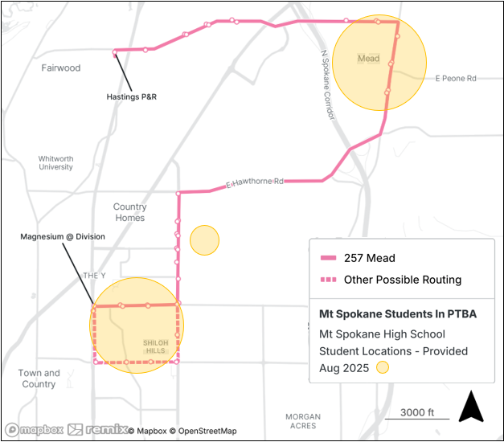

3.4 Timeline of Changes
Spokane Transit Authority operates three service changes a year. The changes included herein are proposed to occur with the timeline in Table 9 below.
Table 9 – Timeline of Changes
2026 Signup Period | Revision to Route(s)
May (May 17, 2026) | 12 Southside Medical Shuttle
September (September 20, 2026) | 20 SFCC
September (September 20, 2026) | 23 Maple/Ash
September (September 20, 2026) | 33 Wellesley*
September (September 20, 2026) | 35 Francis/Market*
September (September 20, 2026) | 36 North Central
September (September 20, 2026) | 223 Shadle/Indian Trail
September (September 20, 2026) | 257 Mead Service Concept
* Interline changes only—discussed more in Section 3.2 above (Notable Interline Changes)

4.0 Special Considerations

4.1 Title VI Implications
In compliance with Title VI of the Civil Rights Act of 1964, this report includes a statement of the impacts of the proposed service changes on minority and low-income transit users. Section 601 of Title VI of the Civil Rights Act of 1964 states:
No person in the United States shall, on the grounds of race, color, or national origin, be excluded from participation in, be denied the benefits of, or be subjected to discrimination under any program or activity receiving Federal financial assistance.
STA’s 2026 Service Revisions represent projected systemwide growth of approximately 1.38% above existing service (September 2025) of 540,325 annualized revenue service hours. According to Connect Spokane: A Comprehensive Plan for Public Transportation, this is classified as a minor service change because the proposed system-wide growth is less than 2% of STA’s total revenue hours and not a reduction of hours. Since the service change is not considered major, a Title VI report is not required per Annex 2 listed in Connect Spokane.

4.2 Paratransit Impacts
Paratransit service is provided to persons whose disability precludes them from accessing or traveling on Fixed Route bus service. As a requirement of the Americans with Disabilities Act that it is complementary of Fixed Route service, Spokane Transit adheres to the mandate to provide the service within ¾ of a mile of each Fixed Route inside the PTBA. Paratransit Policy 1.2 of the Comprehensive Plan for Public Transportation states that Spokane Transit will “adhere to a consistent boundary for Paratransit service availability relative to the maximum Fixed Route service footprint and span provided.” Where there are exceptions, this policy makes it relatively simple to identify most locations that will be impacted by changes in routes that affect the Paratransit boundary.
With the proposed Route 36 extension east along Wellesley and north on Freya Street, a couple of small areas will be newly eligible for paratransit service North of the proposed end-of-line, paratransit service would be available to just south of Freya Street and its intersection with Market Street. Homes in a small sliver east of US-395 between Julia and Yale streets also become paratransit eligible.
To the east of the proposed Route 36 extension, the north/south overhead power lines at Custer Street become the approximate eastern boundary for a new rectangular area of paratransit service between Rich Avenue and Francis Avenue to the north. A small area southwest of Havana Street’s nonexistent intersection with Lyons Avenue also becomes eligible.
Figure 8 – New Paratransit Area, Route 36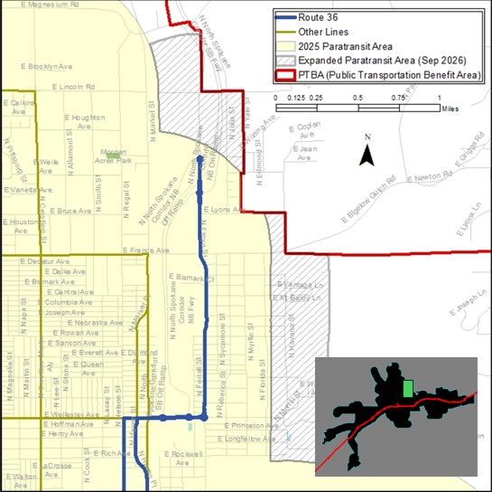

Based on the service concept in Section 3.3 above, the paratransit boundary would also expand to the north of the Route 36 expanded area. The paratransit area would expand east of its current far north boundary to the current PTBA boundary which lies east of Mead. This expanded area encompasses the area of approximately 3/4 mile north of Farwell Road to 3/4 mile south of Hawthorne Road within the PTBA (see Figure 9 below). This area is well populated and includes the central Mead community.
Figure 9 – New Paratransit Area, Route 257